**Code for Chapter 6**

Ex 6.1

**Stepwise regression**

Step1

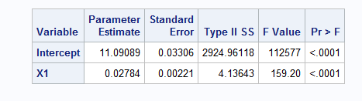

Step 2

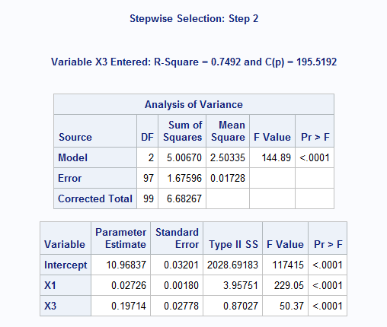

Step 3

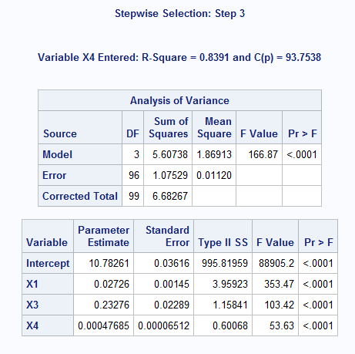

Step 4

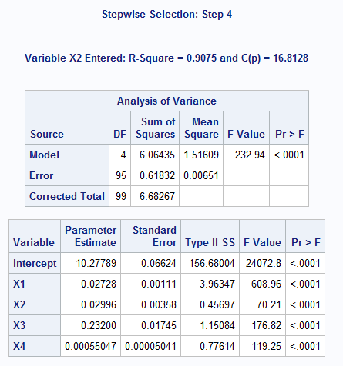

Step 5

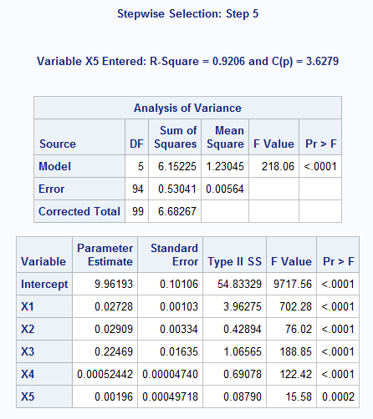

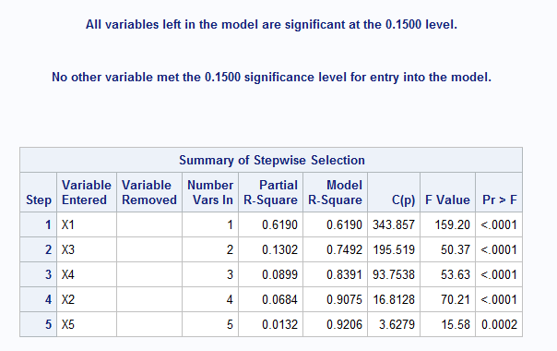

**data** execsal2;

input id Y X1 X2 X3 X4 X5 X6 X7 X8 X9 X10;

datalines;

1 11.4436 12 15 1 240 170 1 44 5 0 21

2 11.7753 25 14 1 510 160 1 53 9 0 28

3 11.3874 20 14 0 370 170 1 56 5 0 26

4 11.2172 3 19 1 170 170 1 26 9 0 24

5 11.6553 19 12 1 520 150 1 43 7 0 27

6 11.1619 14 13 0 420 160 1 53 9 0 27

7 11.6457 18 18 1 290 170 1 43 7 0 22

8 11.1927 2 17 1 200 180 1 31 10 0 26

9 11.5954 14 13 1 560 180 1 43 7 0 23

10 11.1360 4 16 1 230 160 1 36 10 0 25

11 11.5327 8 18 1 540 150 1 39 8 1 21

12 11.5268 19 15 1 90 180 1 47 7 1 30

13 11.9144 23 16 1 560 180 1 47 7 1 23

14 10.9526 5 15 0 470 150 1 44 7 1 21

15 11.3783 3 16 1 340 190 1 33 6 1 29

16 11.7830 22 17 1 70 200 1 50 7 1 22

17 11.4109 24 14 0 160 180 1 49 6 1 26

18 11.6579 22 16 1 160 190 1 51 9 1 25

19 11.5405 13 18 1 110 180 1 33 7 1 24

20 11.8629 21 16 1 410 180 1 59 7 0 24

21 11.4175 10 13 1 370 190 1 49 7 0 26

22 11.2037 11 12 1 180 170 1 39 5 0 25

23 11.5229 12 19 1 60 200 1 39 7 0 24

24 11.3551 10 19 1 60 180 1 37 8 0 27

25 11.8372 26 17 1 110 200 1 48 9 0 24

26 11.3181 7 15 1 280 190 1 45 6 0 23

27 11.3563 7 19 1 110 180 1 29 10 0 23

28 11.2292 10 19 0 300 170 1 41 6 0 23

29 11.3794 23 14 0 220 170 1 53 6 0 27

30 11.7527 12 15 1 570 200 1 41 9 0 26

31 11.2910 6 16 1 240 180 1 33 9 0 25

32 11.4175 15 16 0 300 150 1 38 6 0 25

33 11.6046 15 18 1 260 170 1 41 8 0 22

34 11.1662 8 13 1 150 160 1 37 5 0 29

35 11.5560 18 19 0 350 160 1 38 10 0 29

36 11.1732 2 13 1 370 190 1 26 6 0 21

37 11.3551 13 14 1 150 160 1 52 10 0 21

38 11.3998 12 17 0 480 190 1 33 9 0 20

39 11.7345 21 15 1 310 180 1 52 7 0 22

40 10.6643 3 12 0 340 150 1 23 7 0 25

41 11.7361 20 16 1 520 160 1 43 6 0 28

42 11.7134 20 19 1 200 170 1 44 9 0 26

43 11.5815 20 17 0 490 160 1 40 5 0 30

44 11.0186 1 15 0 570 180 1 30 8 0 30

45 10.9988 2 17 1 70 160 1 37 6 0 23

46 11.4690 9 17 1 300 160 1 37 10 0 20

47 11.3574 11 17 0 190 160 1 41 6 0 25

48 11.3953 21 13 0 500 160 1 47 8 0 24

49 11.8706 20 20 1 390 170 1 47 6 0 21

50 11.6009 17 16 0 520 180 0 49 9 0 24

51 11.9621 24 12 1 530 200 0 60 9 0 23

52 11.0837 2 17 0 590 190 0 28 9 0 27

53 11.5703 9 13 1 560 170 0 45 8 0 22

54 11.2159 2 18 0 600 190 0 38 6 0 23

55 11.2810 13 12 0 390 170 0 48 8 0 24

56 11.5768 14 18 1 110 170 0 53 9 0 26

57 11.5750 18 13 1 190 190 0 55 10 0 25

58 11.2567 10 14 1 110 160 0 34 9 0 30

59 11.7707 21 13 1 430 190 0 59 9 0 26

60 11.3218 11 14 0 440 150 0 31 8 0 23

61 11.7448 26 15 1 210 190 0 54 7 0 27

62 11.7110 22 18 1 320 160 0 57 5 0 22

63 11.4742 3 16 1 560 180 0 38 10 0 29

64 11.7668 17 18 1 450 190 0 53 8 0 24

65 11.1872 2 16 1 410 180 0 35 6 0 24

66 10.9819 4 18 0 70 150 0 43 6 0 20

67 11.2810 8 17 1 90 190 0 34 8 0 25

68 11.4731 13 15 1 290 160 0 33 6 0 23

69 11.4606 3 18 1 530 180 0 27 8 0 24

70 11.3964 13 16 0 420 170 0 47 8 0 25

71 11.5973 25 19 0 150 200 0 49 10 0 28

72 11.4648 11 15 1 500 190 0 44 8 0 21

73 11.1732 2 17 0 430 190 0 36 8 0 20

74 12.0634 26 17 1 570 190 0 49 6 0 29

75 11.5806 20 20 1 90 150 0 59 9 0 27

76 11.5129 19 12 1 340 160 0 54 9 0 22

77 11.5199 12 13 1 440 170 0 41 8 0 27

78 11.9369 22 18 1 500 160 0 55 7 0 24

79 11.4648 13 13 0 570 180 0 37 6 0 27

80 11.2554 2 15 1 560 190 0 34 10 0 22

81 11.3457 15 14 1 160 170 0 54 9 1 25

82 11.4360 12 13 1 390 190 0 35 6 1 24

83 11.3609 13 19 0 370 200 0 40 7 1 29

84 11.2823 5 17 1 330 160 0 40 6 1 22

85 11.2910 8 17 0 560 170 0 42 7 1 25

86 11.6448 21 20 0 590 180 0 46 8 1 27

87 11.2709 5 16 1 290 200 0 28 9 1 24

88 11.3771 9 18 0 440 180 0 37 7 1 28

89 11.5415 19 15 0 480 190 0 42 10 1 28

90 11.6639 23 19 1 130 150 0 55 9 0 24

91 10.8493 3 12 0 440 190 0 38 10 0 22

92 11.5759 13 19 1 310 150 0 51 6 0 29

93 11.5991 22 17 0 370 200 0 55 10 0 29

94 11.1065 9 12 0 180 160 0 39 7 0 22

95 11.6182 7 19 1 520 200 0 40 10 0 22

96 11.3278 10 18 0 90 180 0 34 10 0 28

97 11.9798 25 18 1 590 160 0 64 10 0 21

98 11.7159 10 19 1 480 200 0 48 5 0 26

99 11.1169 3 19 1 80 160 0 27 7 0 28

100 11.4917 16 17 0 380 160 0 50 7 0 29

;

**run**;

**proc** **reg** data=execsal2;

model Y=X1 X2 X3 X4 X5 X6 X7 X8 X9 X10/ selection=stepwise slentry=**0.15** slstay=**0.15**; /*stepwise regression with entry alpha=0.15, stay alpha=0.15; usually slentry <= slstay so we can get variables involved*/

**run**;

**Forward selection**

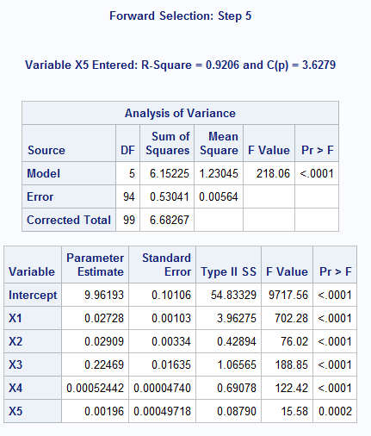

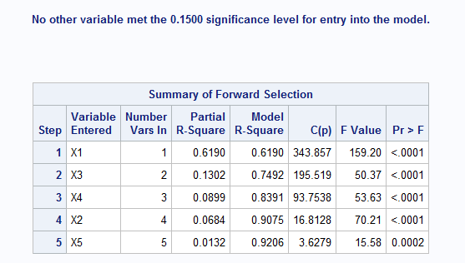

**proc** **reg** data=execsal2;

model Y=X1 X2 X3 X4 X5 X6 X7 X8 X9 X10/ selection=forward slentry=**0.15** slstay=**0.15**; /*forward regression with entry alpha=0.15, stay alpha=0.15 usually slentry <= slstay so we can get variables involved*/

**run**;

**Backward selection**

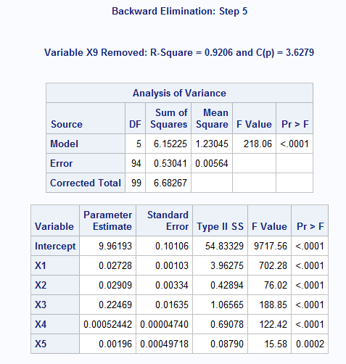

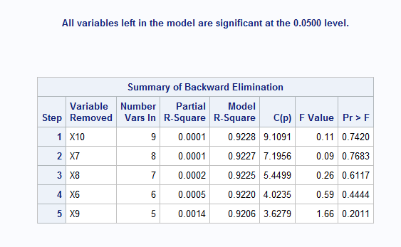

**proc** **reg** data=execsal2;

model Y=X1 X2 X3 X4 X5 X6 X7 X8 X9 X10/ selection=backward slentry=**0.05** slstay=**0.05**; /*backward regression with entry alpha=0.05, stay alpha=0.05 usually slentry <= slstay so we can get variables involved*/

**run**;

Ex 6.2

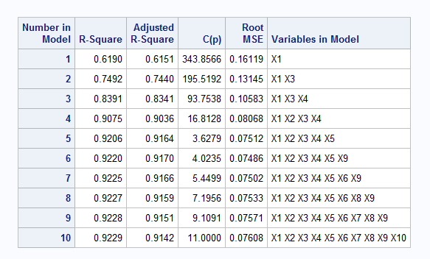

**proc** **reg** data=execsal2;

model Y=X1 X2 X3 X4 X5 X6 X7 X8 X9 X10/ selection=rsquare adjrsq cp rmse best=**1**; /*selection=rsquare meaning select possible models by highest rsqure for each size; best=option specifies the maximum number of subset models to be displayed for each size*/

**run**;

**Output for press in model 5 (x1,x2,x3,x4,x5 get involved)**

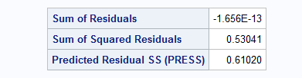

**PROC** **reg** data=execsal2;

model Y=X1 X2 X3 X4 X5/r; /*selection=rsquare meaning select possible models by highest rsqure for each size; best=option specifies the maximum number of subset models to be displayed for each size*/

**run**;